Day 12 — MongoDB + Redis
Results Document
Author: Sheshikala | March 12, 2026
1. MongoDB CRUD — mongo_crud.py
Practiced all CRUD operations. Used nested documents for storing hyperparameters and metrics.

Screenshot 1 — CREATE and READ operations:
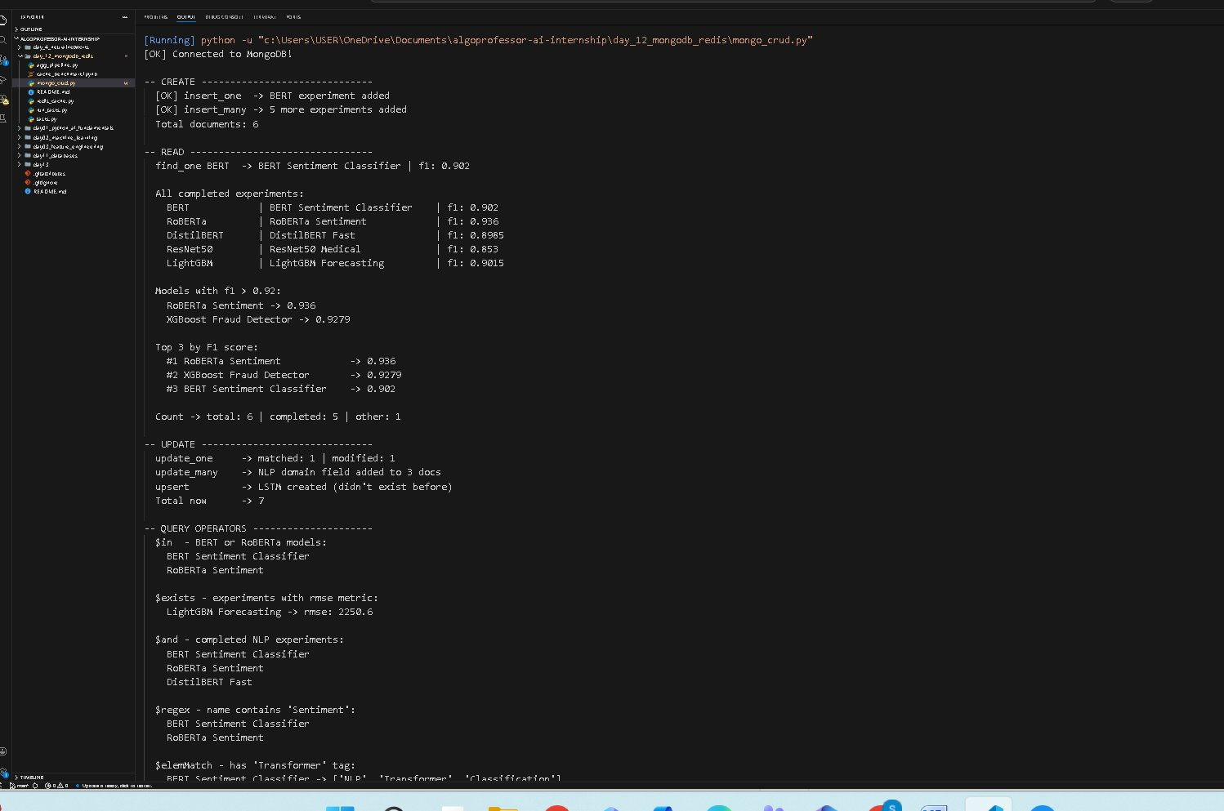
My observation: insert_one and insert_many both worked fine. find() with sort by f1 returned top 3 correctly — RoBERTa 0.936, XGBoost 0.9279, BERT 0.902. Dot notation on nested metrics field also worked.

Screenshot 2 — UPDATE, QUERY OPERATORS, INDEXES, DELETE:
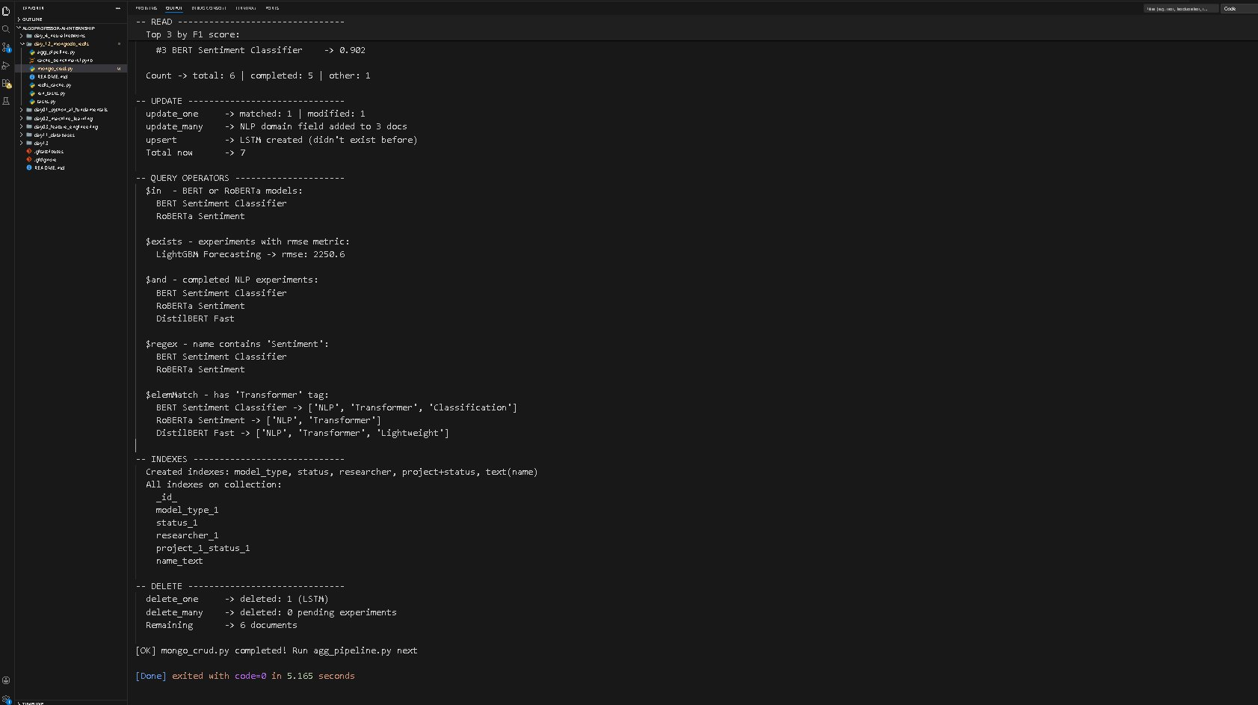
My observation: update_many added NLP domain field to 3 docs in one shot. Upsert auto-created LSTM document which didn't exist before. delete_many deleted 0 because no pending experiments left after update. 5 indexes created including compound and text index.

2. Aggregation Pipeline — agg_pipeline.py
Built 6 pipelines using $match, $group, $lookup, $unwind, $addFields, $facet stages.

Screenshot 3 — Pipelines 1, 2, 3:
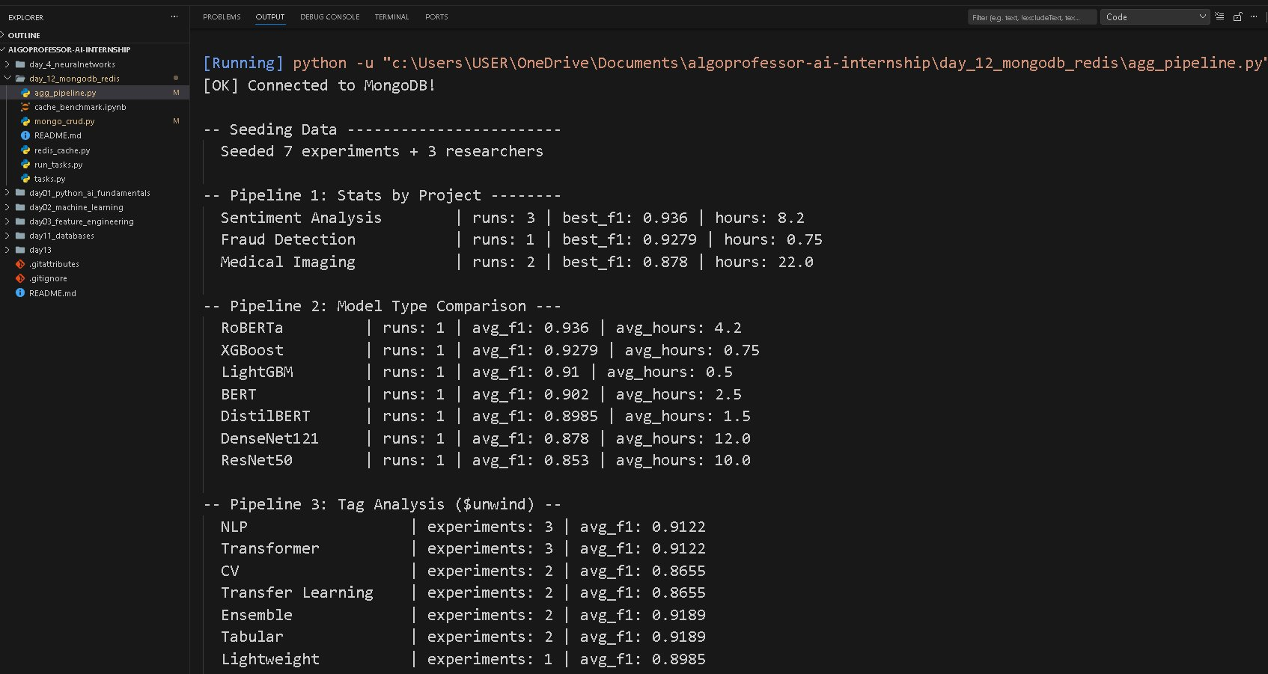
My observation: Pipeline 1: Sentiment Analysis had most runs (3), best F1 0.936. Pipeline 2: RoBERTa highest avg F1 but also most hours (4.2). Pipeline 3 used $unwind to flatten tags array — NLP and Transformer appeared 3 times each.

Screenshot 4 — Pipelines 4, 5, 6:
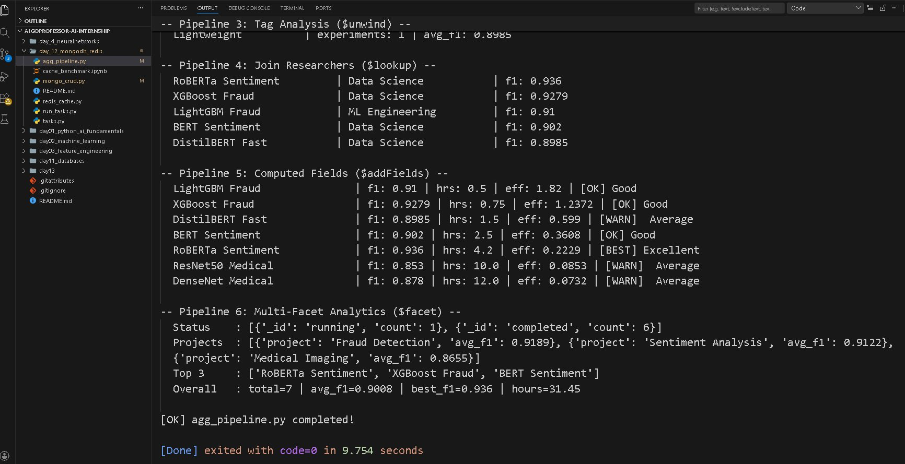
My observation: Pipeline 4 $lookup joined experiments + researchers — LightGBM belongs to ML Engineering dept, rest to Data Science. Pipeline 5 computed efficiency score: LightGBM most efficient (1.82) despite lower F1, RoBERTa worst (0.22) due to 4.2 training hours. Pipeline 6 $facet ran 4 sub-pipelines in one query — overall avg F1 0.9008 across 7 experiments.

3. Redis Cache — redis_cache.py
Demonstrated all 5 Redis data types plus Cache-Aside pattern, Pub/Sub messaging, TTL and eviction.

Screenshot 5 — Strings, Hashes, Lists, Sets:
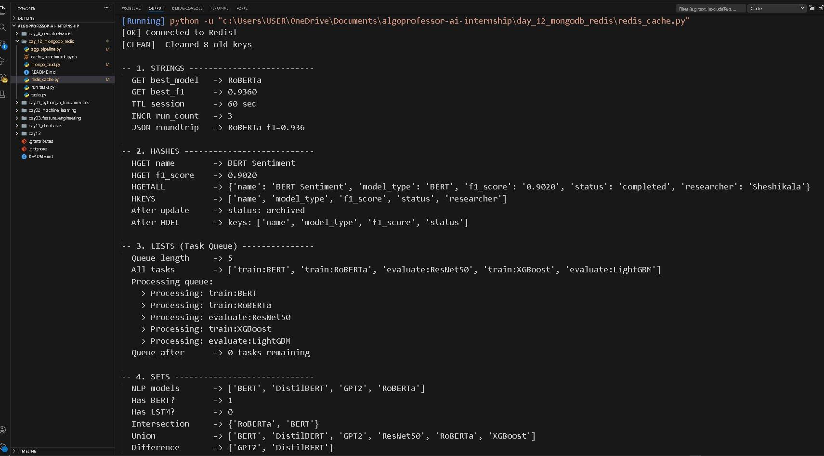
My observation: Strings stored best_model and best_f1 with 60s TTL. Hashes: HDEL removed only the researcher field without affecting other fields. Lists processed all 5 tasks FIFO, queue empty after. Sets: intersection of NLP and done models correctly returned only BERT and RoBERTa.

Screenshot 6 — Sorted Sets, Cache-Aside, Pub/Sub, TTL:
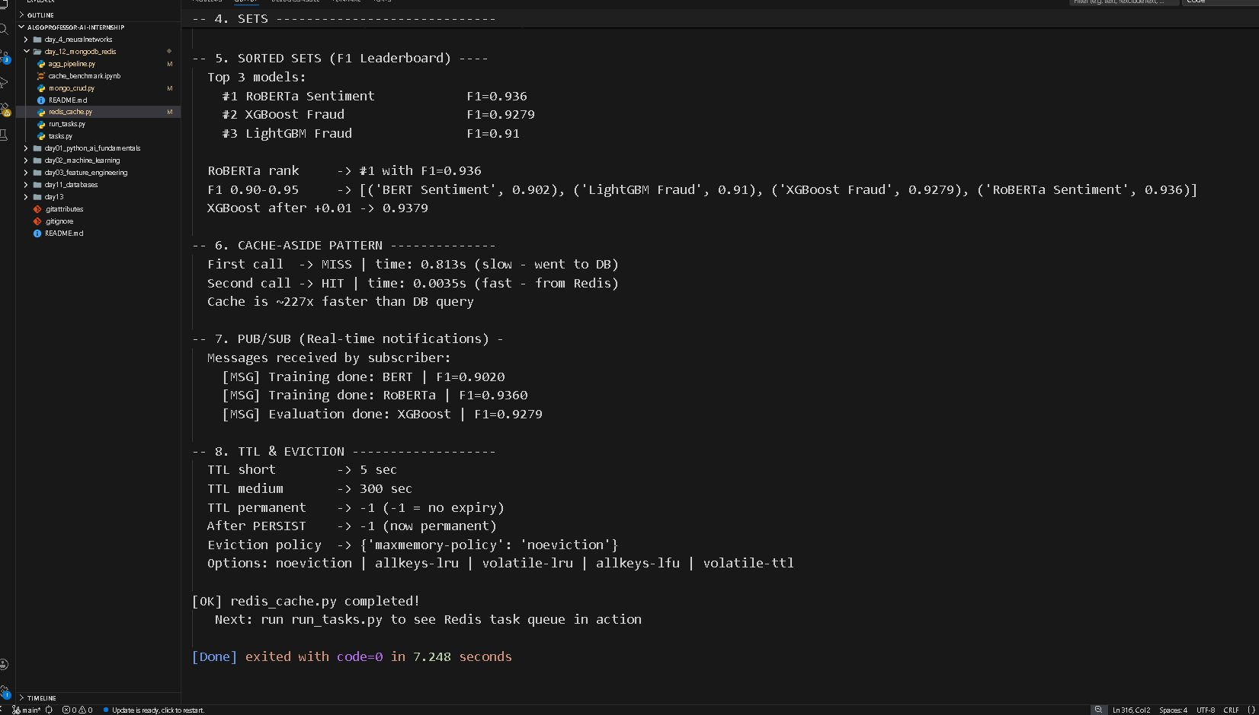
My observation: Sorted Set leaderboard auto-ranked by F1: RoBERTa #1 (0.936), XGBoost #2 (0.9279), LightGBM #3 (0.91). Cache-Aside was 227x faster than MongoDB — first call 0.813s, second call 0.0035s. Pub/Sub received all 3 training messages in real time. PERSIST made key permanent, TTL showed -1.

4. Task Queue — run_tasks.py
Used Redis LIST as task queue. Producer pushed 5 ML tasks, worker processed FIFO, results stored in MongoDB.

Screenshot 7 — Enqueue and Processing:
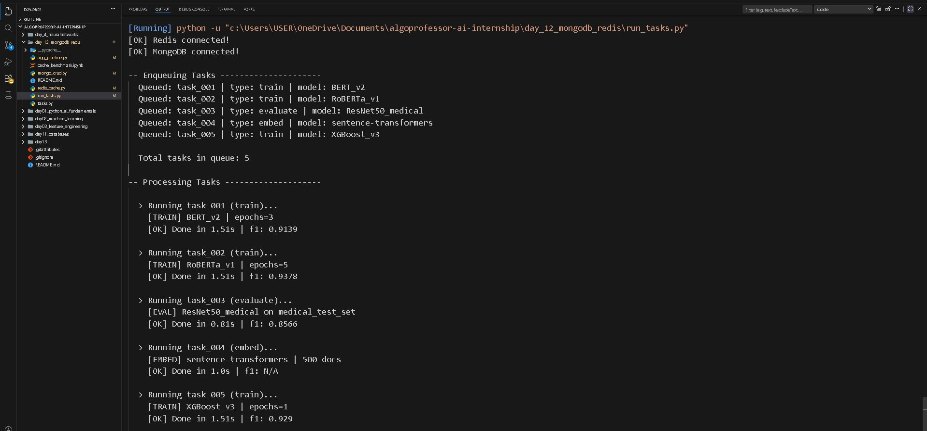
My observation: All 5 tasks queued with type and model info. Tasks processed in correct FIFO order — BERT first, XGBoost last. Each task showed its type clearly: train, evaluate, embed.

Screenshot 8 — Final Stats and Results Summary:
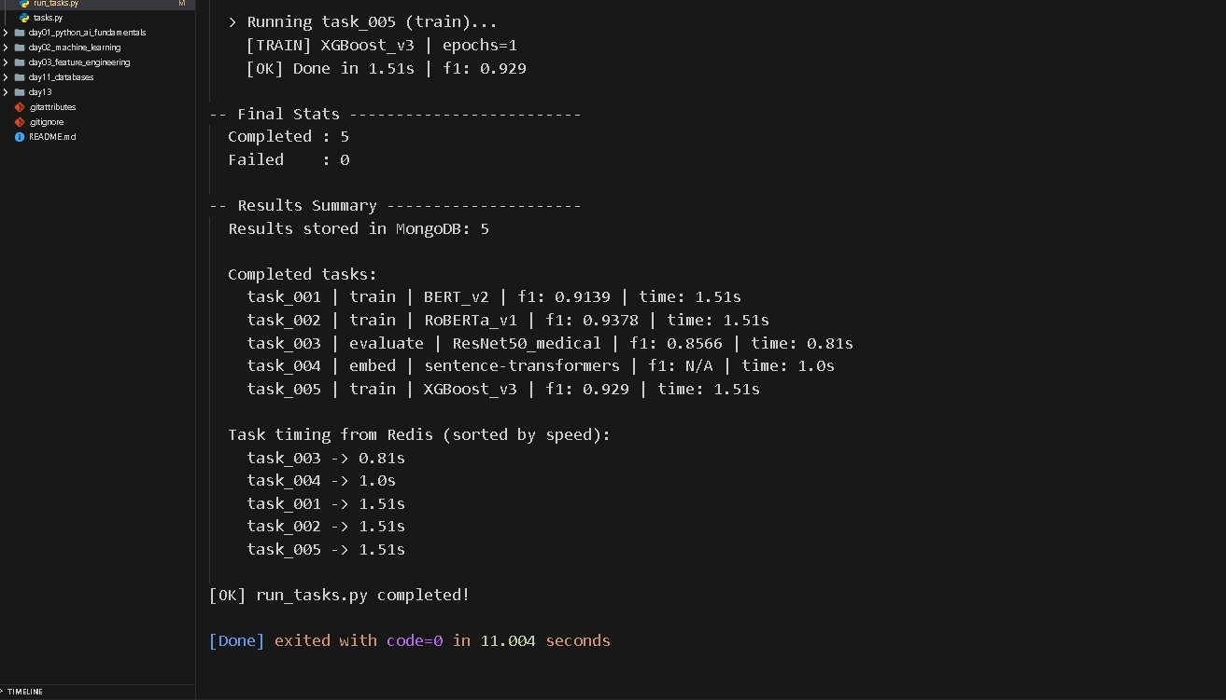
My observation: All 5 completed, 0 failed. evaluate task fastest at 0.81s — no training epochs needed. embed task 1.0s. All 3 train tasks 1.51s each. Task timing also stored in Redis Sorted Set sorted by speed. Results stored in MongoDB for later querying.

5. Key Learnings
MongoDB — used for permanent storage with rich queries. Redis — used for speed (cache), queuing (list), real-time (pub/sub), ranking (sorted set).

Important findings from today:
Redis Cache-Aside was 227x faster than MongoDB for repeated reads
LightGBM had best efficiency score 1.82 — high F1 with only 0.5 hrs training
$facet ran 4 analytics in one MongoDB query — very useful for dashboards
Upsert created LSTM document automatically when it didn't exist
Redis Sorted Set handled leaderboard ranking with zero sorting code

Day 12 Complete — All 4 files ran successfully with 0 errors

